The Jewish connection to stem cell research

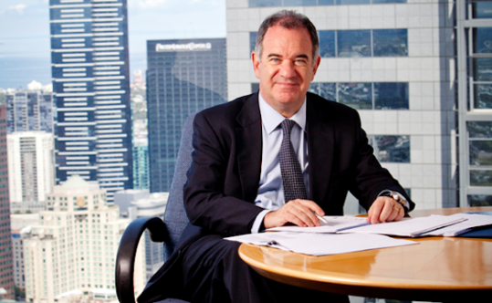
Silviu Itescu
More than a decade ago, Silviu Itescu and Michael Schuster were conducting research in a laboratory at Columbia University and made a discovery involving a type of human stem cell that could be used to treat rats during a heart attack.
The revolutionary finding demonstrated the power of the stem cell to help heal human medical conditions and led to the formation of Mesoblast, which identifies itself as the largest biotechnology regenerative medicine company in the industry.
“It was clear that there was a major opportunity based on results we found, and it was also clear that if we wanted to take stem cells to clinical development, it would have to be done outside the research and academic environment,” Itescu, the company’s CEO, told the Journal during a visit to Los Angeles last month.
The child of Holocaust survivors who fled communist Romania with him to Australia in 1965 to escape anti-Semitism, Itescu has been working with his colleagues on a medicinal product targeting major therapeutic areas such as cardiovascular, orthopedic, oncological and autoimmune systems. They are focusing on spinal diseases and working on bone marrow transplant results.
Stem cells are unspecialized cells that can renew themselves through cell division; they also can become tissue- or organ-specific cells with special functions, according to the National Institutes of Health.
This allows them to help regenerate systems that have become dysfunctional, such as the back or the heart. The product and dosage for each area is different, as there is no uniform formula for the problematic parts.

“It’s a broad spectrum [we’re covering]. It’s based on understanding the capabilities of our technology, based on understanding how our technology targets different disease stages and understanding where the unmet needs are in those diseases, so [we can] offer a unique benefit that goes over and above what else is out there,” Itescu said.
The Food and Drug Administration requires approval for each phase of clinical trials in order to move forward with the execution process for the stem cell drugs Mesoblast is creating. The company was approved for Phase 2 studies earlier this year, with clinical trials in the United States for treatment based on mesenchymal precursor cells. The next step is to get approval for Phase 3, in which clinical trials would take place in the U.S. and abroad.
Steven Peckman, associate director of the Eli and Edythe Broad Center of Regenerative Medicine and Stem Cell Research at UCLA, said the possibilities with stem cell research are exciting.
“Stem cells can have a dramatic impact on society,” he said. “If you could develop stem cell treatment that would cure cancer or HIV or [be] able to regenerate a healthy heart from a damaged heart, I’d say you’d have an incredible impact. It has the potential to change the practice of medicine where we use the body’s own cells to cure and treat disease.”
When Mesoblast was first getting started in the post-Sept. 11 world, Itescu said it was difficult to get venture capital funding in the United States. He added that the U.S. was “really in a very negative situation for innovative, new things,” resulting in the company’s debut in Australia.
The initial clinical data allowed Mesoblast to bring in commercial and pharmaceutical partners, which helped raise more capital to strengthen its capabilities. One of its biggest partners is Teva, an Israeli pharmaceutical company focused on neurological diseases.
“It happened for commercial reasons because it made commercial sense,” Itescu said of the partnership. “As a Jew, I certainly am pleased and have an affinity for a strong, commercially focused Israeli company, but first and foremost is their real expertise in real neurological disease.”
Other partners are in the United States and abroad, including some in Singapore and Japan.
“We’ve matured and grown, we’ve had to change culture in the company, so we’re no longer a small startup,” Itescu said. “We still have to be fairly hungry and innovative, but we’ve got to have more experience [and] executional ability.”
Mesoblast’s work has garnered Itescu invitations to speak at conferences across the globe. Last month, he participated in the Israstem conference in Israel for research on stem cell therapy and then attended the Goldman Sachs Global Healthcare Conference in Orange County.
Itescu has been recognized for his achievements, including receiving the inaugural Key Innovation award from the Pontifical Council for Culture and the Stem for Life Foundation in Vatican City in April 2013.
Mesoblast has remained an Australian public company, with its footprint in the United States. At around 120 employees — more than two-thirds of them in the U.S. — they have $240 million in the bank “to do real programs,” Itescu said.
For the past 10 years, Mesoblast has kept the same goal: taking a technology believed to have the opportunity to create new medicines with a completely different mode of action, according to Itescu, to meet the needs that available drugs cannot.
“We’re almost there. We’re at the finish line,” Itescu said.
Over the next couple of years, he said, Mesoblast hopes to be the first company to launch a stem cell product on the American market.
“We’re very close,” Itescu said. “But we’ll get there.”

